Franco  - haley |  |  | UI/UX Designer
Franco  - haley |  |  | Web Developer
 |  |  | CONTACT
October 14, 2025  [COMPANY]  RE: UI/UX Designer |  |  |  407-473-2549
October 14, 2025  [COMPANY]  RE: UI/UX Designer |  |  |  francohaley@gmail.com
October 14, 2025  [COMPANY]  RE: UI/UX Designer |  |  |  francohaley.com
Dear Director of Human Resources,

I am excited to apply for the UI/UX Designer position at [COMPANY], as your mission to enhance communication through innovative language solutions resonates deeply with my passion for user-centric design. With a decade of experience in UI/UX design and a strong background in quality control and project management, I am confident in my ability to lead the design of seamless, engaging user interfaces that elevate the user experience across web and mobile applications.

In my previous role as a UI/UX Designer III, I honed my skills in conducting user research and usability testing, which allowed me to deeply understand user needs and iterate on design solutions effectively. My artistic approach enables me to create compelling wireframes, prototypes, and high-fidelity mockups that clearly communicate design ideas and workflows. I thrive in collaborative environments, actively working with cross-functional teams to define and implement innovative strategies that align with project goals.

I share [COMPANY]'s commitment to inclusivity and empowerment and believe that effective design can break down barriers in communication. I stay attuned to the latest industry trends and best practices, continuously advocating for design excellence.

I would love the opportunity to contribute to [COMPANY]’s mission and bring my creative thinking, attention to detail, and collaborative spirit to your talented team. Thank you for considering my application. I look forward to the possibility of discussing how my experience aligns with the exciting work at [COMPANY].

Sincerely,

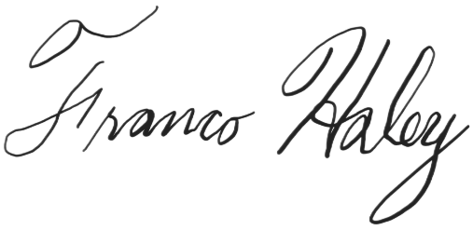
Franco Haley

Enclosure

